**1. Write a VBA code to enter your name in A1 Cell using Input Box and once you enter the name display a message box that says the name has been entered.**

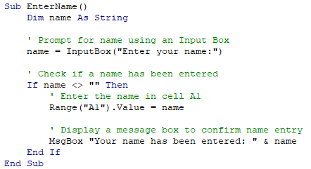

**2. What are Userforms? Why are they used? How to fill a list box using for loop.**

UserForms in VBA (Visual Basic for Applications) are custom dialog boxes or windows that allow users to interact with your Excel application or VBA program. UserForms provide a graphical user interface (GUI) for collecting input, displaying information, or performing specific actions. They can contain various controls such as buttons, text boxes, checkboxes, list boxes, etc.

Data Entry: UserForms can be used to collect input from users in a structured and user-friendly manner. They provide a convenient way to gather information, validate inputs, and perform actions based on user selections.

Custom Menus or Toolbars: UserForms can act as custom menus or toolbars that provide additional functionality beyond the default Excel interface. They can contain buttons, checkboxes, and other controls to trigger specific actions or macros.

Displaying Information: UserForms can be used to display important information or messages to users. They allow you to format and present information in a more organized and visually appealing way.

Automation and Workflow: UserForms can automate tasks or guide users through complex processes by providing step-by-step instructions, input fields, and progress indicators.

Insert a UserForm in your VBA project:

Open the VBA Editor in Excel by pressing Alt+F11.

Right-click on your VBA project in the Project Explorer window and choose Insert > UserForm to add a new UserForm to your project.

Add a ListBox control to the UserForm:

With the UserForm open in design mode, locate the ListBox control in the Toolbox (press Ctrl+T to display the Toolbox if it's not visible).

Click and drag the ListBox control onto the UserForm to add it.

Add code to fill the ListBox using a For loop:

Double-click on the UserForm to open the code window for the UserForm.

In the code window, enter the following code:

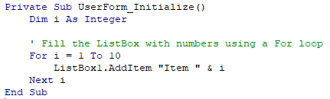

**3. What is an array? Write a VBA code to enter students and their marks from the below table.**

In VBA (Visual Basic for Applications), an array is a collection of elements of the same data type. It allows you to store multiple values of the same kind in a single variable. Arrays in VBA can be one-dimensional, two-dimensional, or multi-dimensional.

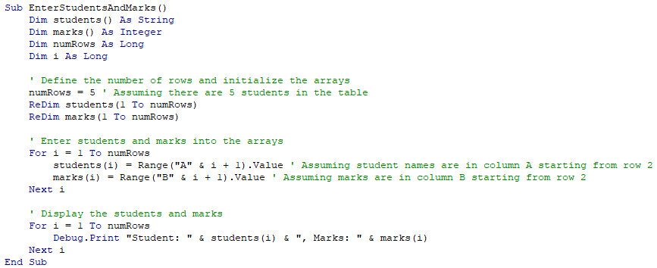

**4. Use the following data to create a pie chart using VBA code. Use Font- ‘Times new Roman’, Size -14, B old, Title - Piechart’ and you are perto use colours as per your taste.**

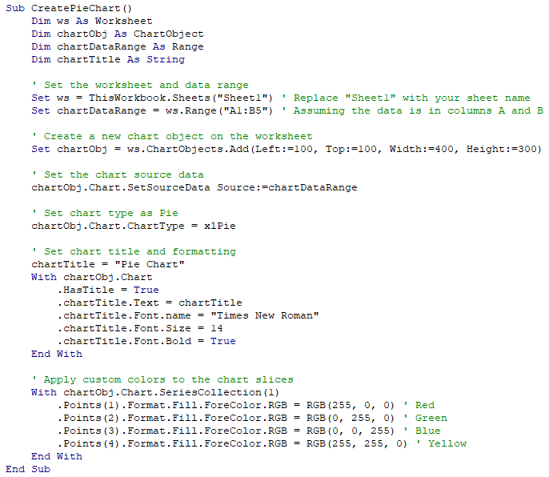

**5. Check the dataset in the link given below and create a pivot table using VBA showing the sales for the year from stationary category.**

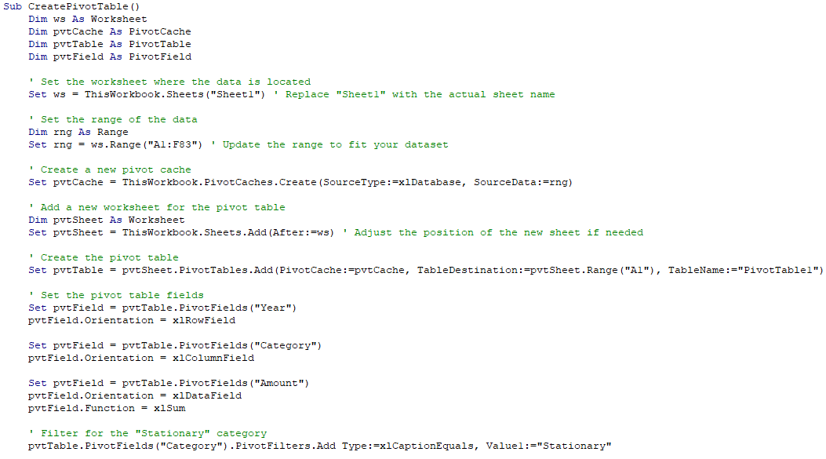

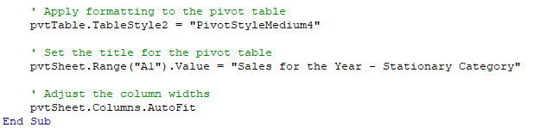

**6. Write step by step procedure to protect your workbook using a password.**

Open the Excel Workbook.

Click on the "File" tab and select "Protect Workbook" from the drop-down menu.

Choose "Encrypt with Password" from the options.

Enter a password in the "Password" field and click "OK".

Re-enter the same password in the "Reenter password" field and click "OK".

Save the workbook by clicking "File" and selecting "Save".

Your workbook is now protected with a password.